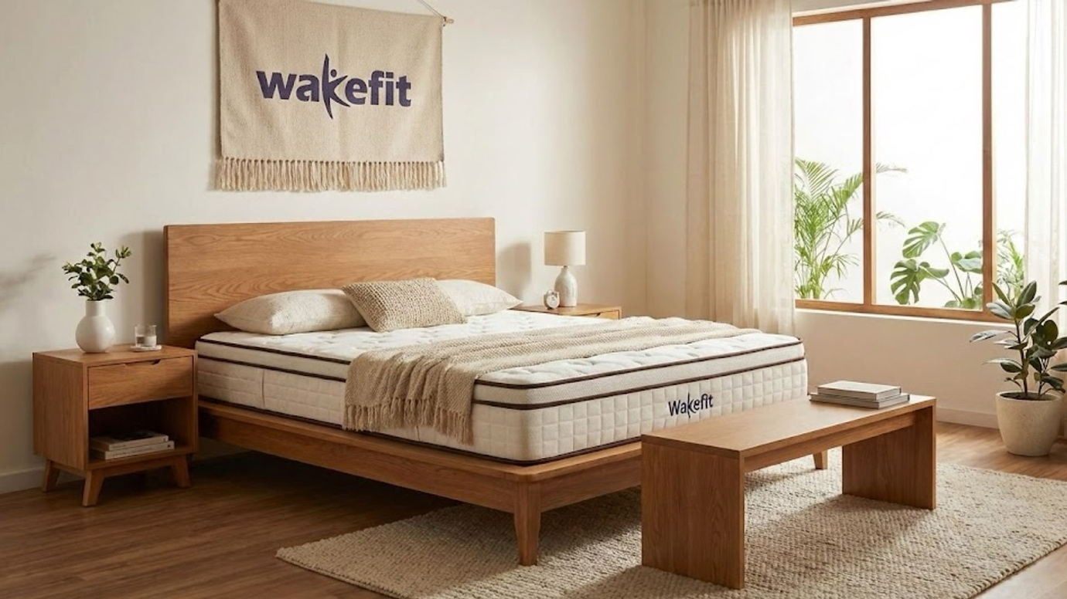

Company Overview:

Imagine starting a venture in the small corner of Bengaluru, selling just one thing: mattresses. A few years later, the same company is launching an IPO (Initial Public Offering) to become a prominent player in the home market. That company is known as Wakefit Innovations Limited – expanding from a “sleep specialist” to a full-blown “home solutions giant”.

Founded in 2016, Ankit Garg and Chaitanya Ramalingegowda identified a fragmented mattress market and set out to provide affordable solutions. It is a D2C business operating through websites and apps, as well as COCO stores (company-owned, company-operated). Serving over 9.9 million orders and a vision to reach 2 lakh crore organised homes, the company is poised to enter the next phase: expanding to 100+ stores and penetrating Tier 2 and Tier 3 markets.

Structure of the Offer:

- A fresh issue of 4,682 crores is used to repay debt, fund expansion, and provide working capital for growth.

- Offer for sale of 5.2 crores, to be sold by the existing shareholders. This included investors such as Peak XV (25 million shares) and the two founders, Ankit Garg (7.7 M) and Chaitanya (4.5M).
- The offer is 100% Book-Built, with 75% allocated to Institutional investors, 15% to high-net-worth individuals, and 10% to retail customers like you and me.
Page 71

Key Financial Metrics:
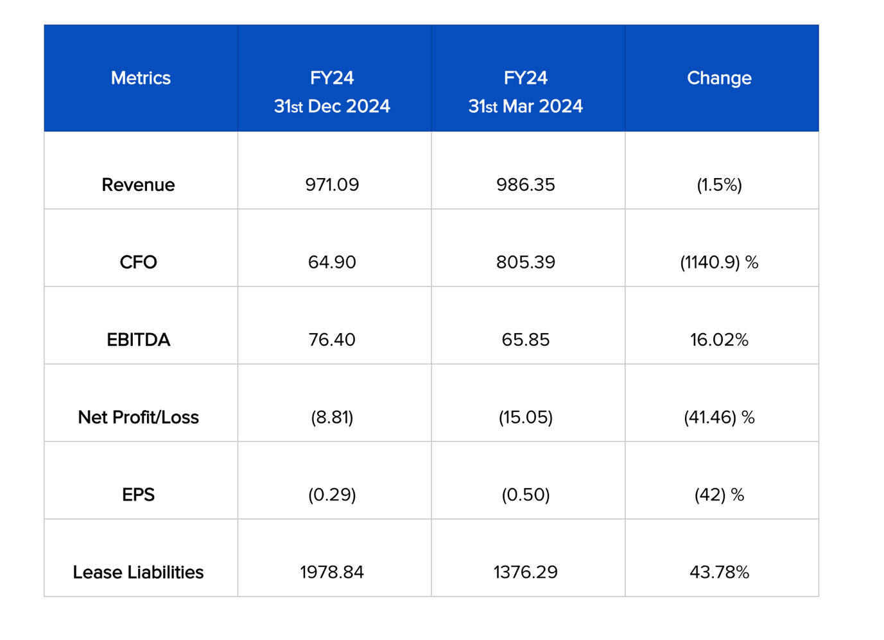

Page 262
Risks associated:

- A large share of revenue comes from mattresses. Any change in customer tastes, the entry of competitors, or a drop in disposable income could significantly impact the company.

- The company has no long-term contracts with its suppliers and meets demand through spot purchases. Any price hikes or supply shortages would halt the company's production.

- The company does not have its own logistics and depends on third-party services. An increase in cost or supply issues could impact delivery services and customer satisfaction.

- The company has significant lease liabilities, trade payables, and working capital borrowings, which create a cash crunch and pose risks in the event of an emergency or liquidation.

- Any increase in interest rates would increase the company's finance costs due to higher borrowings.
Page 33-67

Financial Insights:
- The company has been growing at a rate of 28% CAGR from (FY22-24). Losses have declined by 90%, and operating leverage has improved.

- They have stocked chemicals and wood before time to hedge against rising prices. This has led to additional cash outflows for the company, reducing cash availability for FY24.

- The D/E ratio (Debt to Equity) has been below 0.1x, indicating the company does not rely on external borrowings.

- There has been a breach of company defaults or covenants, indicating positive cash management by the company.
Page 262

Conclusion:
The IPO of Wakefit Innovations Limited is a dual-mandate offering. On one hand, the fresh issue demonstrates the company’s ambition to raise capital for expansion. On the other hand, the considerable Offer for Sale component, dominated by leading partners such as Peak XV and Verlinvest, supports the company's financial summary.
For investors, it is an opportunity to invest in a successful, growth-oriented brand. However, the first-time issue underscores the need for due diligence. The story of Wakefit’s IPO is ultimately a tale of transition and a significant step in the home market, balancing growth capital with investor liquidity needs.

Authored By: Aryaveer Batra

Disclaimer:
This article is intended solely for information and educational purposes and does not constitute any financial, investment or legal advice. The data and analysis presented are based on publicly available information, including the company’s Red Herring Prospectus (RHP) and reputable financial news sources. Readers are advised to conduct their own research and consult with a qualified financial advisor before making any investment decisions. The author and publisher have no responsibility for any monetary losses or damages from reliance on the information contained herein.
- Stock Analysis

